Name: celebrate

Surname: Mashaba

Student number: ST10055395

Module name: IT professional practice

Assessment type: Assignment 2

Group 8

**Question 1**

**1.**

Ethical implication of creators passing their values onto AI and humanoid robots. When humans suppose of artificial intelligence the image that comes to mind is robots moving around that give mechanical replies. Many forms of AI are there but humanoid forms of robots are the most popular applications. Various movies depicted humanoid that are science fiction based movies The earliest humanoid created in 1495 was an suit of armor and it performed many human operation.

It performed functions, sitting, walking, talking, etc. In the early days, humanoids were for research and for creating prosthetic for human. Lately, created humanoids are not created for research purposes but various functionalities. Modern humanoids are designed to perform different human-related daily tasks. It occupies different roles in the sector of employment in various companies.

Some of them are in the role of personal assistant, reception, teacher, front desk officer, and so on. The process of developing humanoids includes invention, developing, etc. Developing a humanoid is quite a complex task. It takes a lot of work and research. The process of developing humanoids includes invention, developing a humanoid is a complex task.

It requires a lot of research work. Inventors and engineers go through complex processes and challenge while designing a humanoid. First-grade devices like sensors and devices like actuators are a very crucial part and a mistake that may result in collapse. Humanoid work on tasks such as moving, and talking and perform actions through certain characteristics such as sensors and hardware as actuators.

Humanoids works on various features. Robots designed for human action have sensors built in them that assist them in understanding their surroundings and environments. Some devices have in-built cameras that enable users to note the environment. Motors guide robots in moving and gesture-making. A humanoid has these motors that are known as actuators.

Actions performed by human body are examined at the initial to get a wide picture of what features are to be imitated. Then, one has to identify the purpose of creating a humanoid. Humanoid robots are created for several purposes. Some robots are created foe experiments and research work. While some are created for other purposes such as entertainment.

Humanoid were created to carry out tasks such as personal assistants that make use of AI, which helps in healthcare and elderly homes. The next step researchers are required to perform before a working humanoid is created that identifying body parts and testing them to identify functions. Then, they undergo the coding process which is the most vital stage in creating a humanoid.

Codes designed for specific tasks help the humanoid to perform tasks and provide answers when asked. Sophia is the first robot humanoid. Designed by the USA and currently granted citizenship of KSA. Jia is another project that was developed by the Chinese university of science and technology.

Humanoid robot is a wonderful machine it is a fascinating field of concentrate with its capacity of getting data from its encompassing and completing physical work simply like human. The general idea of humanoid robot is utilizing distinctive sort sensors to secure data and performing diverse undertaking dependent on the procured data by utilizing the facial expressive head, hand, body and legs.

A humanoid robot can convey to human with outward appearance and hand motions. It even can utilize its hand to convey things and move from spot to put. Be that as it may, these are as yet not adequate in our everyday exercises, the humanoid robot ought to have the option to adjust existing capacity, adapt to change and ready to adapt new abilities.

# References

David J. Bruemmer, M. S. S., 2003. *sciencedirect.* [Online]   
Available at: https://www.sciencedirect.com/topics/computer-science/humanoid-robots  
[Accessed 15 October 2022].

**2**

Al ethics is a system of moral principles and techniques intended to inform the development and responsible use of artificial intelligence technology. As AI has become integral to products and services, organizations are starting to develop AI codes of ethics.

An AI code of ethics, also called an AI value platform, is a policy statement that formally defines the role of artificial intelligence as it applies to the continued development of the human race. The purpose of an AI code of ethics is to provide stakeholders with guidance when faced with an ethical decision regarding the use of artificial intelligence

Isaac Asimov, the science fiction writer, foresaw the potential dangers of autonomous AI agents long before their development and created the three Laws of Robotics as a means of limiting those risks. In Asimov’s code of ethics, the first law forbids robots from actively harming humans by refusing to act. The second law orders robots to obey humans unless the orders are not in accordance with the first law.

The third law orders robots to protect themselves insofar as doing so is in accordance with the first two laws. The rapid advancement of AI in the past five to 10 years has spurred group of experts to develop safeguards for protecting against the risks of AI to humans. One such group is the nonprofit institute founded by MIT cosmologist Max.

The institute worked with AI researchers and developers as well as scholar from many disciplines to create the 23 guidelines now to as the AI principles.AI is a technology designed by humans by humans to replicate, augment or replace human intelligence. These tools typically rely on large volumes of various types of data to develop insights.

Poorly designed projects built on data is faulty, inadequate or biased can have unintended, potentially harmful, consequences.

Moreover, the rapid advancement in algorithmic system means that in some cases it is not clear to us how the AI reached its conclusion, so we are essentially relying on system we can’t explain to make decisions that could affect society. An AI ethics framework is important because it shines a light on the risks and benefits of AI tools and establishes guidelines for its responsible use.

Coming up with a system of moral tenets and techniques for using AI responsibly requires the industry and interested parties to examine major social issues and ultimately the question of what makes us human.

Firms now use AI to manage sourcing of materials and products from suppliers and to integrate vast troves of information to aid in strategic decision-making, and because of its capacity to process data so quickly, AI tools are helping to minimize time in the pricey trial-and-error of product development.

Health care experts see many possible uses for AI, including with billing and processing necessary paperwork. And medical professional expect that the biggest, most immediate impact will be in analysis of data, imaging, and diagnosis. Imagine, they say, having the ability to bring all of the medical knowledge available on a disease to any given treatment decision

In employment, AI software culls and processes resumes and analyzes job interviewees’ voice and facial expression in hiring and driving the growth of what known as ‘hybrid’ job. Rather than replacing employees, AI takes on important technical tasks of their work, like routing for package delivery trucks, which potentially frees workers to focus on other responsibilities, making them more productive and there more valuable to employers

[Online]

Available at: <https://www.sciencedirect.com/topic/computer-science/code-of-ethics>

[Accessed 15 October 2022]

**Question** **2**

Group celebrate mashaba and methembe shabangu

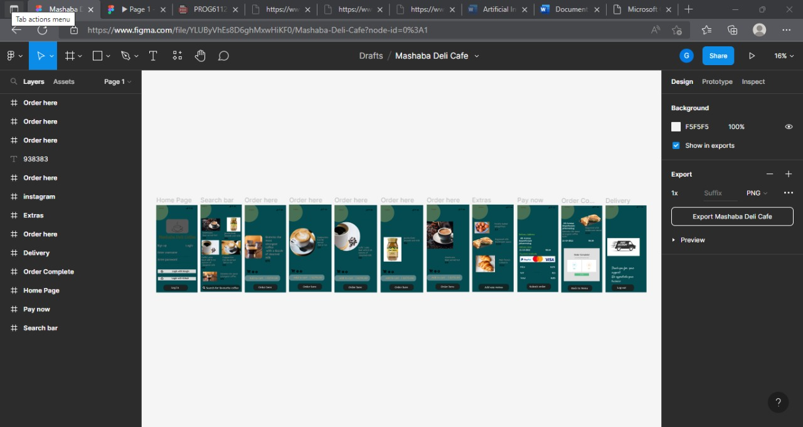

Wireframe

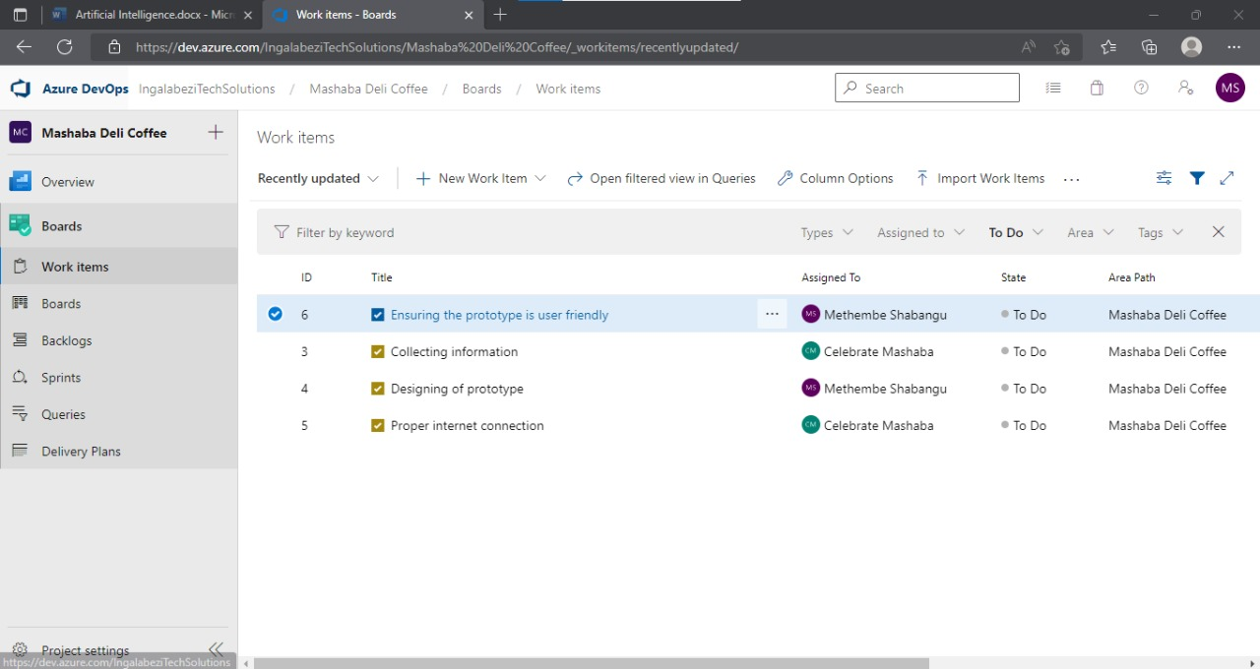

Tasks assigned

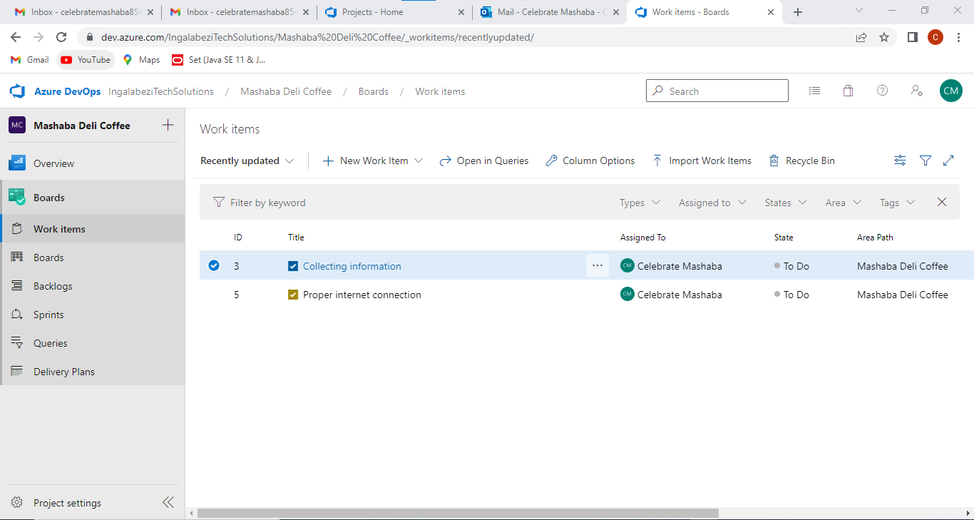

Completion of task

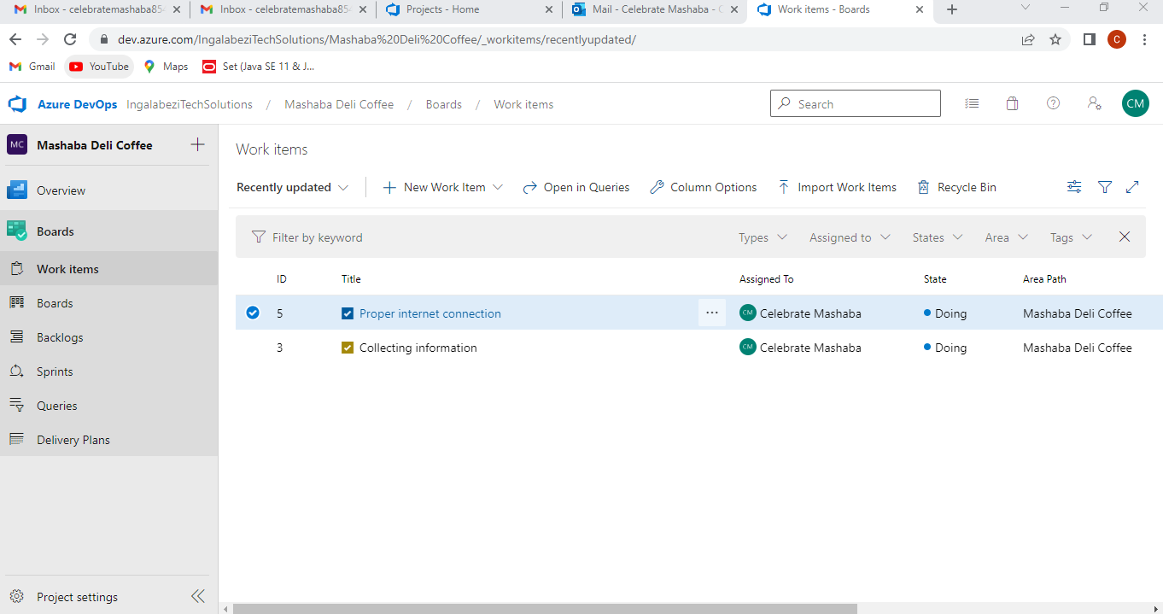

Task are complete

[Online]

Available at: <https://www.figma.com>

[Accessed 15 October 2022]

<https://dev.azure.com/IngalabeziTechSolution>

Licensing and copyright

Apache license- it is a free software license which was written by apache software foundation with the following aims

-to enable users to make use software for any purpose of their liking

-be it to modify, distribute it

-most important it gives developers or create to distribute modified version of their software based on the terms of the license, without of course the worry of royalities

[Online]

Available at: <https://www.sciencedirect.com/computer-science/licensing-copyright>

[Accessed 15 October 2022]

3.

Intellectual property refers to the body of law that protect creative works, designs, and inventions. It also provides registration procedures for the creators and inventors to gain additional right and access to increased protection.

Patent Used to protect inventive ideas or processes, things that are new, useful and nonobvious- patents are what most often come to mind when thinking of IP protection. Patents are also used to protect newly engineered plant species or strain, as well

Typically, innovation teams work to address a common problem facing their organization, industry, or the world at large when developing their ideas. When they have arrived at a solution or concept, they will draw up plans and gather the resources to make it a reality. Prototypes or drawings can be created to provide a more accurate description of the end product or process

A trademark is unlike a patent in that it protects words, phrases, symbols, sounds, smells and color schemes. Trademark are often considered assest that describe or otherwise identify the source of underlying products or services that a company provides, such as the MGM lion roar, the lntel inside logo

A trademark application requires the company or user to provide a clear description and representation of the mark and its uses in conjunction with associated products or services. As with patents, it’s a good idea to partner with outside counsel that specializes in trademark application and/or search services so they can help ensure there is clear path for your desired mark

Copyright do not protect ideas, but rather the manner in which ideas are expressed ‘original works of authorship, written works, arts, Music, architectural drawing, or even programming code for software (most evident nowadays in the video game entertainment). With certain exceptions, copyright allow the owner of the protected materials to control reproduction, performance, new versioning or adaptation, public performance and distribution of the works

Copyright in general attach when the original works become fixed in a tangible medium, but should be registered with the government copyright office for optimal protection in the form of damages, injunction and confiscation. Copyright registration application are much simpler than patents or trademarks, and typically can be obtained by the author alone

Trade secrets are proprietary procedures, system, devices, formulas, strategies or other information that is confidential and exclusive to the company them

The use of IP management software has become a crucial tool for businesses of all size hoping to get a better view of their assest. The impact of tracking intellectual property creation, usage and cost structure is hugely evident in different companies’ abilities to both quickly lunch products and preserve revenue for existing assest

Wireframe acts as a digital diagram or layout of the product

Working model allows you to test the idea of a product to see if it actually function the way you intended

Video prototype are often used to present a product in the form of an animated video or even a simulation that explains and graphically represent a project

[Online]

Available at: <https://www.sciencedirect.com/computer-science/intellectual-property>

[Accessed 15 October 2022]

**Question** **3**

<https://youtu.be/Yml81o7D4ZU>

[Online]

Available at: <https://youtu.be/Yml81o7D4ZU-presentation>

[Accessed 15 October 2022]

|  |  |
| --- | --- |
| **Please note: Attach** this rubric to your work when you submit your **Assignment.** This information needs to be included in the online submission. | |
| **MODULE NAME: IT PROFESSIONAL PRACTICE – ASSIGNMENT 2** | **MODULE CODE: ITPP5112/d** |
| **STUDENT NAME:** | |
| **STUDENT NUMBER:** | |

|  |  |  |  |
| --- | --- | --- | --- |
| **QUESTION 1** | | | |
|  | | | |
| **Tone and structure** | * Document is poorly structured; the tone is   unprofessional; does not comply with the report length requirement. | * A well-structured document covering all   points and complies with the required report length. | * Report has a professional structure and tone;   covers all points and complies with required length. |
| **0 Marks** | **1-3 Marks** | **4-5 Marks** |
| **Marking**  **Criteria** | **Does not meet the required standard**  ***(0% - 49%)*** | **Meets the required standard**  ***(50% - 74%)*** | **Exceeds the required standard**  ***(75% - 100%)*** |
| **The argument is well formulated and supported by academic articles and other resources.** | * No argument or the argument is weak and not supported by academic literature. | * A good argument is formulated, supported by academic literature. | * A very strong argument is made and supported by various sources of academic literature. |
| **0 – 4 Marks** | **5 – 7 Marks** | **8 – 10 Marks** |

|  |  |  |  |
| --- | --- | --- | --- |
| **Marking**  **Criteria** | **Does not meet the required standard**  ***(0% - 49%)*** | **Meets the required standard**  ***(50% - 74%)*** | **Exceeds the required standard**  ***(75% - 100%)*** |
| **The argument links back to the video and refers to the relevant sections in the video being addressed.** | * The argument does not link back to the video and is unrelated to the discussion of human values, ethics, and AI * Not attempted (0). | * The argument and discussion refer to the video and explain how the formulated argument links back to the video. | * The argument is based on the video, refers to various areas in the video where human emotion and values are discussed. |
| **0 Marks** | **1-3 Marks** | **4-5 Marks** |
| **Marking**  **Criteria** | **Does not meet the required standard**  ***(0% - 49%)*** | **Meets the required standard**  ***(50% - 74%)*** | **Exceeds the required standard**  ***(75% - 100%)*** |
| **Code of conducted is created and submitted** | * No code of conduct is submitted (0). * The code of conduct is vague and not related to the video or technology discussed. | * The code of conduct is created and contains general ethical principles, responsibilities of developers and section   on compliance. | * The code of conduct is well thought out, comprehensive and includes general ethical principles, responsibilities, compliance, and   leadership. |
| **0 – 5 Marks** | **5 – 10 Marks** | **10-15 Marks** |
|  |  |  |  |
|  |  |  |  |

|  |  |  |  |  |
| --- | --- | --- | --- | --- |
| **QUESTION 2** | | | | |
| **SECTION 1** | | | | |
| **Marking**  **Criteria** | **Does not meet the required standard**  ***(0% - 49%)*** | | **Meets the required standard**  ***(50% - 74%)*** | **Exceeds the required standard**  ***(75% - 100%)*** |
| **Wireframes for all screens in app** | * No wireframes submitted (0) * The wireframes are of poor quality or incomplete. | | * Good quality wireframes that represent all the required features. | * Additional effort is taken to produce exceptional, professional wireframes that   includes all the necessary features. |
| **0 – 9 Marks** | | **10 – 15 Marks** | **16-20 Marks** |
| **Marking**  **Criteria** | **Does not meet the required standard**  ***(0% - 49%)*** | | **Meets the required standard**  ***(50% - 74%)*** | **Exceeds the required standard**  ***(75% - 100%)*** |
| **Azure Boards** | * No boards are created (0). * Tasks are not broken up well. * Tasks are not assigned well. * No real groupwork present. | | * The tasks are adequately broken up and assigned to group members. * Progression through the tasks is evident. * Group work is evident. | * Additional effort is taken to break down the tasks and create Kanban. |
| **0 – 9 Marks** | | **10 – 15 Marks** | **16-20 Marks** |
| **Marking**  **Criteria** | **Does not meet the required standard**  ***(0% - 49%)*** | | **Meets the required standard**  ***(50% - 74%)*** | **Exceeds the required standard**  ***(75% - 100%)*** |
| **Licensing and Copyright report** | * No report provided (0). * Incomplete explanation of IP and licensing provided. | | * Good explanation of IP and how it applies to the prototype. * Good explanation as to the differences   between the MIT and Apache license and the choice of for the future software. | * An exceptionally detailed explanation of IP and how it relates to the prototypes is applied. * Addition effort is taken to explain the   differences between the two license types and which to apply is provided and motivated for. |
| **0 – 5 Marks** | | **5 – 10 Marks** | **10-15 Marks** |
| **QUESTION 2** | | | | |
| **SECTION 2** | | | | |
| **Marking Criteria** | | **Does not meet the required standard**  ***(0% - 49%)*** | **Meets the required standard**  ***(50% - 74%)*** | **Exceeds the required standard**  ***(75% - 100%)*** |
| **Infographic – motherboard layout** | | * No infographic submitted (0). * The infographic is of poor quality or incomplete. | * Good quality infographic that represents all the required features. | * Additional effort is taken to produce exceptional, professional infographic that   includes all the necessary features. |
| **0 – 4 Marks** | **5 – 7 Marks** | **8 – 10 Marks** |

|  |  |  |  |
| --- | --- | --- | --- |
| **Marking Criteria** | **Does not meet the required standard**  ***(0% - 49%)*** | **Meets the required standard**  ***(50% - 74%)*** | **Exceeds the required standard**  ***(75% - 100%)*** |
| **Infographic – description of each component** | * No descriptions (0). * Incomplete descriptions of components. * Poorly described. | * There are descriptions for all components but poorly described. | * Good to excellent description of the components. |
| **0 – 4 Marks** | **5 – 7 Marks** | **8 – 10 Marks** |
| **Marking Criteria** | **Does not meet the required standard**  ***(0% - 49%)*** | **Meets the required standard**  ***(50% - 74%)*** | **Exceeds the required standard**  ***(75% - 100%)*** |
| **Infographic – description of troubleshooting for each component** | * No troubleshooting descriptions provided (0). * Troubleshooting explanations for a few   components only. | * Troubleshooting explanations provided for all components but the instructions are not clear. | * Troubleshooting explanations provided for all components. * Explanations are detailed and well written. |
| **0 – 5 Marks** | **5 – 10 Marks** | **10-15 Marks** |
| **Marking Criteria** | **Does not meet the required standard**  ***(0% - 49%)*** | **Meets the required standard**  ***(50% - 74%)*** | **Exceeds the required standard**  ***(75% - 100%)*** |
| **Infographics - aesthetics** | * No consideration to aesthetics. * Infographic not pleasing to the eye. * Font is not clear and eye catching. | * Minimal consideration of aesthetics * Colours are not pleasing to the eye * Font is not clear and incorrectly sized | * Well thought out graphical display of information. * Congruence between font and colour. * Information is laid out logically |
| **1 – 2 Marks** | **3 Marks** | **4-5 Marks** |
|  |  |  |  |

|  |  |  |  |
| --- | --- | --- | --- |
| **QUESTION 3** | | | |
| **Marking**  **Criteria** | **Does not meet the required standard**  ***(0% - 49%)*** | **Meets the required standard**  ***(50% - 74%)*** | **Exceeds the required standard**  ***(75% - 100%)*** |
| **Video structure and content** | * No video submitted (0).   features of the application/infographic and is unstructured.   * The video is unprofessional and lacks   detail. | * A well-structured video that covers all the features of the app is provided. * A good level of professionalism is followed in the video. | * Additional effort is taken to provide an exceptional video that covers all the features as well as contains additional elements such as music etc. |
| **0 – 3 Marks** | **4 – 6 Marks** | **7 - 8 Marks** |
| **Marking**  **Criteria** | **Does not meet the required standard**  ***(0% - 49%)*** | **Meets the required standard**  ***(50% - 74%)*** | **Exceeds the required standard**  ***(75% - 100%)*** |
| **Video uploaded to**  **YouTube** | * Not uploaded. | * Uploaded but unlisted or not found with   URL. | * Uploaded and public, easily accessible. |
| **0 Marks** | **1 mark** | **2 Marks** |

# 